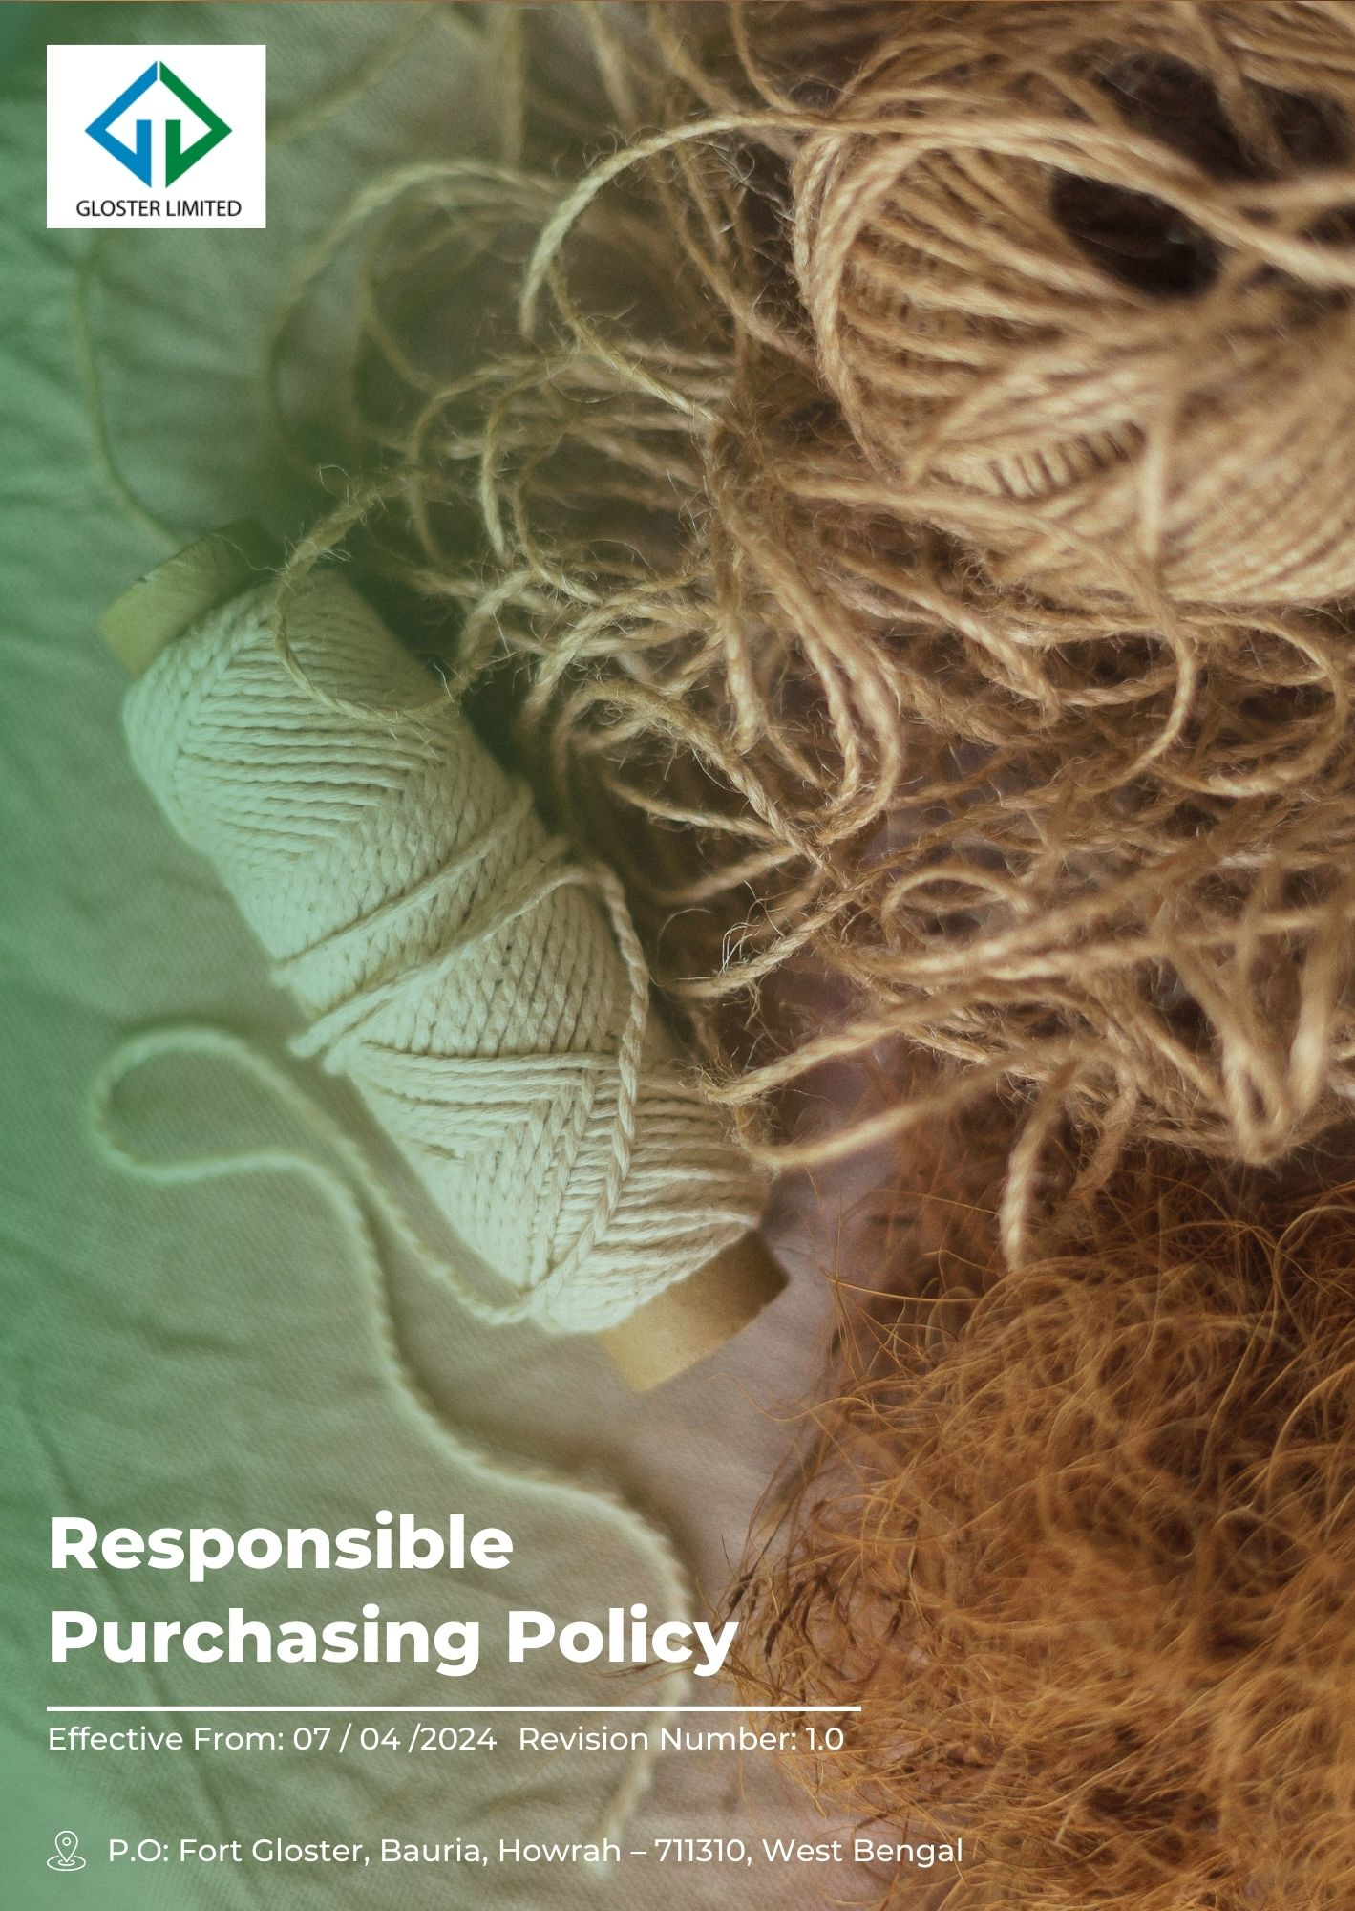
Contents
1) Preamble 3
2) Desired Outcomes 3
3) Scope 3
4) Core Procurement Strategies 4
5) Specific Requirements 5
6) Accountability 6
7) Risk Management 7
8) Progress Update 7
9) Transparency and Communication 8
10) Ongoing Development 8
11) Review Cycle 9
12) Employee Acknowledgement Form 10

Preamble
Gloster Limited is deeply committed to sustainable business practices that ensure the long-term viability of our operations and the well-being of our stakeholders. Our Sustainable Procurement Policy is designed to integrate environmental, social, and economic considerations into our procurement processes specific to the jute industry. By sourcing jute and other materials responsibly, we aim to minimize our environmental footprint, promote fair labor practices, and support the local economy. This policy reflects our dedication to ethical business practices and aligns with our broader sustainability goals, ensuring that our supply chain is resilient, responsible, and resource-efficient.

Desired Outcomes
- To integrate sustainability criteria into all procurement decisions in the jute manufacturing industry.
- To reduce the environmental impact of our jute supply chain.
- To promote social responsibility and fair labor practices among our jute suppliers.
- To support local economies and communities through responsible jute sourcing.
- To continuously improve our procurement processes to enhance sustainability in jute manufacturing.

Scope
This Policy applies to all employees (at all levels), stakeholders (internal and external), partners, contractors, customers, suppliers, and any other individual or entity working on behalf of Gloster Limited. It also applies to the following sites.
Sr.No. | Unit Name | Address
1 | GLOSTER LIMITED-Ananya Unit | P.O: Fort Gloster, Bauria, Howrah – 711310, West Bengal
2 | GLOSTER LIMITED-Head Office | Head Office, 21, Strand Road, Kolkata 700001

Core Procurement Strategies
This section outlines our commitment to building a sustainable supply chain that prioritizes environmental responsibility, ethical labor practices, and economic empowerment. We are dedicated to continuous improvement and achieving these goals through a comprehensive set of strategies.
The following sections detail our core procurement strategies across various areas:
- General Targets
- To strengthen ethical sourcing, we have implemented a supplier due diligence framework and aim to complete ESG risk assessments for 50% of high-risk suppliers by FY 2029-30 from the baseline FY 2023-24.
- To improve supplier transparency, we have introduced mandatory sustainability disclosures and aim to obtain ESG-related information from 50% of active suppliers by FY 2029-30 from the baseline FY 2023-24.
- To ensure responsible business conduct, we have integrated ESG clauses into procurement contracts and aim to cover 100% of supplier agreements with responsible sourcing requirements by FY 2029-30 from the baseline FY 2023-24.
- To address supply chain non-compliances, we have implemented corrective action plans and aim to close 100% of identified supplier non-compliances within defined timelines by FY 2029-30 from the baseline FY 2023-24.
- To enhance supply chain governance, we have established annual supplier reviews and aim to conduct sustainability performance evaluations for at least 50% of key suppliers by FY 2029-30 from the baseline FY 2023-24.
- To strengthen ESG compliance across the supply chain, we aim to reinforce implementation of the Supplier Code of Conduct and obtain formal acknowledgement of ESG requirements from 90% of active suppliers by FY 2029–30 from the baseline FY 2023–24.
- Environmental Issues in Supply Chain Management
- To reduce our carbon footprint, we source cotton yarn and webbing locally and aim to reduce transportation emissions by 10% by FY 2029-30 from the baseline FY 2022-23. Additionally, we aim to source our raw materials locally whenever possible, which will further reduce transportation emissions.
- To minimize our environmental footprint, we're actively seeking partnerships with certified suppliers who adhere to environmental standards like ISO 14001 and prioritize responsible sourcing and processing, aiming to reduce new material use by 10% by FY 2029-30 from the baseline FY 2022-23,
- We're striving for. 15% supplier adoption of our code of conduct to ensure responsible environmental practices throughout our supply chain by FY 2029-30 from the baseline FY 2022-23
- We also aim to spread awareness among our procurement staff through various training and awareness sessions on environmental issues, We aim to cover 100% of procurement staff in Sustainable Procurement Training sessions by FY 2029-30 from the baseline FY 2022-23.
- Social Issues in Supply Chain Management
- To ensure fair labor practices, we are in progress to implement audit on our jute suppliers regularly and aim to increase compliance with labor standards to 100% by FY 2029-30 from the baseline FY 2022-23.
- To support local communities, we have adopted a policy to source jute from local farmers and aim to increase local procurement by 10% by FY 2029-30 from the baseline FY 2022-23.
- To achieve greater diversity in our business partnerships, we aim to have 10% of our suppliers be women-owned businesses by FY 2029-30 from the baseline FY 2022-23.
- To support small jute enterprises, we have introduced a supplier development program and aim to increase small vendors participation by 20% by FY 2029-30 from the baseline FY 2022-23.
- We also aim to strengthen awareness among our procurement staff on social responsibility through targeted training and awareness sessions on social and labor issues, and aim to cover 100% of procurement staff in social sustainability and responsible sourcing training by FY 2029–30 from the baseline FY 2022–23.
- Technological Issues in Supply Chain Management
- We aim to increase the adoption of sustainable technologies in jute processing by collaborating with innovative suppliers, targeting a 5% increase in technology adoption by FY 2029-30 from the baseline FY 2022-23.

Specific Requirements
Our Sustainable Procurement Policy includes specific requirements to guide our procurement processes:
- Environmental Criteria: Suppliers must demonstrate efforts to reduce their carbon footprint, manage waste, and use sustainable materials. They are required to provide evidence of their environmental management practices and compliance with relevant regulations.
- Social Criteria: Suppliers are required to adhere to fair labor practices, support local communities, and promote diversity. This includes compliance with international labor standards, such as the ILO conventions, and support for local economic development initiatives.
- Economic Criteria: Suppliers must engage in fair trade practices, support SME participation, and ensure equitable compensation for workers. We will prioritize suppliers who can demonstrate a commitment to economic fairness and sustainability.
- Technological Criteria: Suppliers should invest in and adopt technologies that reduce environmental impact and enhance sustainability. This includes the use of renewable energy, efficient manufacturing processes, and innovative materials.

Accountability
Gloster Limited is committed to ensuring accountability across all levels of our procurement processes. The following roles and responsibilities are established to uphold our Sustainable Procurement Policy:
- Senior Management: Responsible for integration into strategic business plans. They ensure resources are allocated to support sustainability initiatives and that sustainability goals are embedded in corporate objectives.
- Procurement Team: Tasked with implementing sustainable procurement practices, including evaluating suppliers based on environmental, social, and economic criteria. They are also responsible for supplier relationship management, ensuring that sustainability requirements are communicated and adhered to.
- Compliance Officer: Responsible for Implementation and Review for this policy, Monitors adherence to the policy and conducts regular audits to ensure compliance with sustainability standards. The Compliance Officer is also responsible for reporting compliance issues and developing corrective action plans in collaboration with the procurement team.
- Sustainability Committee: Comprising representatives from various departments, the committee meets quarterly to review progress, address challenges, and propose new initiatives to enhance sustainability.
- All Employees: Expected to adhere to sustainable procurement practices and report any deviations or concerns to the Compliance Officer. Employees are encouraged to participate in sustainability training sessions and contribute to a culture of continuous improvement.

Risk Management
Effective risk management is essential to the success of our Sustainable Procurement Policy. We will:
- Risk Assessments: Conduct regular risk assessments to identify and mitigate potential sustainability-related risks in our supply chain. These assessments will cover environmental, social, and economic risks, and will involve input from stakeholders and experts.
- Contingency Plans: Develop and implement contingency plans to address identified risks, ensuring business continuity and resilience. Contingency plans will include alternative sourcing strategies, crisis management protocols, and communication plans.
- Monitoring and Evaluation: Continuously monitor and evaluate the effectiveness of our risk management strategies, making adjustments as needed to address emerging risks. We will use key performance indicators (KPIs) and regular audits to track progress and identify areas for improvement.
- Supplier Risk Management: Work closely with suppliers to identify and manage risks in their operations. This will include joint risk assessments, capacity building, and support for suppliers in developing their own risk management plans.

Progress Update
We are dedicated to regularly updating our stakeholders on the progress of our Sustainable Procurement Policy. Progress updates will be provided through:
- Quarterly Reports: Detailed reports on key performance indicators (KPIs) and progress towards our sustainability goals. These reports will include data on carbon footprint reduction, fair labor compliance, and local sourcing percentages.
- Annual Sustainability Report: Comprehensive overview of our achievements, challenges, and future plans related to sustainable procurement. This report will be shared with all stakeholders, including investors, customers, and suppliers.
- Internal Meetings: Regular team meetings to discuss progress, share best practices, and address any issues. These meetings will include presentations from the procurement team, compliance officer, and sustainability committee.
- Stakeholder Surveys: Periodic surveys to gather feedback from stakeholders on our sustainable procurement practices and areas for improvement.

Transparency and Communication
We are committed to maintaining transparency and open communication regarding our sustainable procurement efforts. This includes:
- Public Disclosure: Regularly publishing our sustainability reports and progress updates on our website. We will also participate in industry forums and conferences to share our experiences and learn from others.
- Stakeholder Engagement: Hosting forums and meetings with stakeholders to discuss our sustainable procurement initiatives and gather input. These events will provide opportunities for dialogue and collaboration with key stakeholders, including suppliers, customers, and community representatives.
- Clear Communication: Ensuring that our sustainability expectations and requirements are clearly communicated to all suppliers and partners. We will provide detailed guidelines and support to help suppliers understand and meet our standards.
- Feedback Mechanisms: Establishing feedback mechanisms to allow stakeholders to share their views and suggestions on our sustainability practices. This will include online feedback forms, suggestion boxes, and regular stakeholder meetings.

Ongoing Development
At Gloster Limited, ongoing development is central to our Sustainable Procurement Policy. We continuously seek new ways to enhance our procurement practices by integrating the latest sustainability standards and best practices. Our commitment includes regular training for employees, innovative partnerships with eco-conscious suppliers, and investing in technologies that reduce environmental impact. We also engage stakeholders through surveys and forums to ensure our initiatives remain effective and aligned with their expectations. By fostering a culture of continuous improvement, we aim to set industry benchmarks in sustainable procurement.

Review Cycle
The Compliance Officer at Gloster Limited conducts annual and on an ad hoc basis review of the Sustainable Procurement Policy. This review includes evaluating supplier compliance, assessing progress against sustainability targets, and identifying areas for improvement. The findings are documented in an annual report, ensuring transparency and accountability.
Policy | Responsible Person | Signature | Date
Prepared by | Compliance Officer |  | 30th March 2023
Approved by | General Manger |  | 01st April 2023

Reviewed by | Review Date | Signature | Revised No. | Change Summary
Compliance Officer | 01st April 2024 |  | 1.0 | Updated section of “Progress Update”
Compliance Officer | 01st April 2025 |  | 1.1 | Included additional targets
Next Review date: 01st April 2026

Employee Acknowledgement Form
I acknowledge that I have received, read, and understood the Responsible Sourcing Policy of Gloster Limited. I am aware of my responsibilities in adhering to the principles and guidelines set forth in this policy, which include environmental, social, economic, and technological criteria for procurement.
By signing this form, I commit to upholding the sustainable procurement practices outlined in the policy and to actively participating in training sessions and initiatives aimed at enhancing sustainability within our supply chain. I understand that my adherence to this policy is crucial in promoting ethical business practices, reducing our environmental footprint, and supporting local economies and communities.
I also acknowledge the role of the Compliance Officer and the Sustainability Committee in monitoring and reviewing our procurement processes and commit to reporting any deviations or concerns promptly.
Employee Name: ____________________________
Employee Signature: _________________________
Date: ______________________

